Landing Page: Your Email Campaign’s Perfect Soul Mate

Do you know why it is hard to find a soul mate? It is because they are expected to understand you in a better way and help you throughout your life. Likewise, a landing page that speaks exactly what your email expresses is your email campaign’s soul mate. But it is hard to find your email campaign’s perfect soul mate as 44% of inbound marketers’ link their email campaigns to their home page and break the fragile heart of a landing page. Ideally, an email campaign and a landing page should both work together.
When partners go hand-in-hand they become the best team. Similarly, when the power couple (email campaign + landing page) comes together, it pumps up the conversion rate up to 50%. Blimey, isn’t it? Many inbound marketers are already nailing their email campaigns by creating a killing landing page that carries the thorough essence.
Everything is understood best when it comes with an example. Straight from the monastery, Monks bring to you 6 Email Campaigns with “Totally Nailing It” Landing Pages.
Birchbox
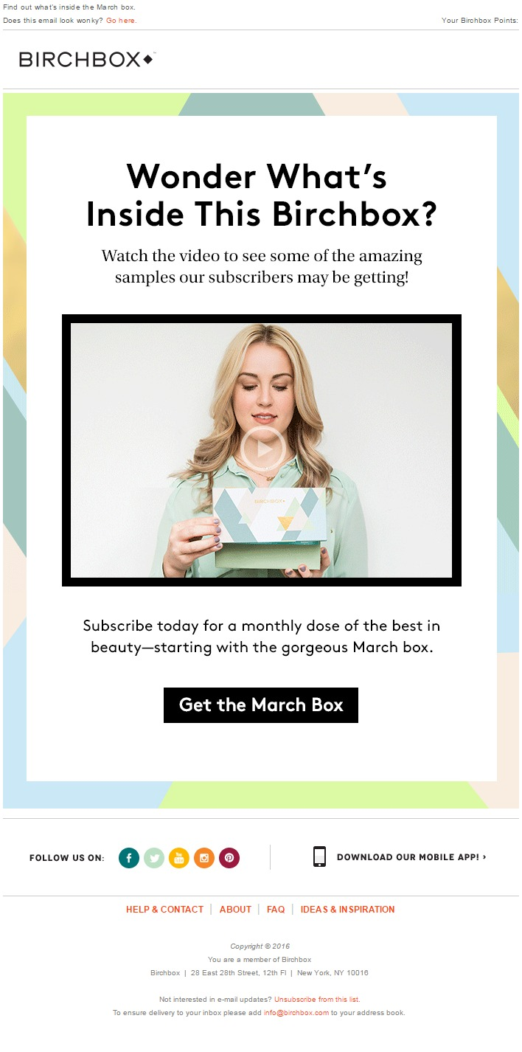
When it comes to creating a brilliant email campaign, Birchbox puts its creative mind forward and brings an email that instantly wins the subscribers’ hearts. But, this is not enough as when it comes to tempt their subscribers’ the crisp CTA is there.
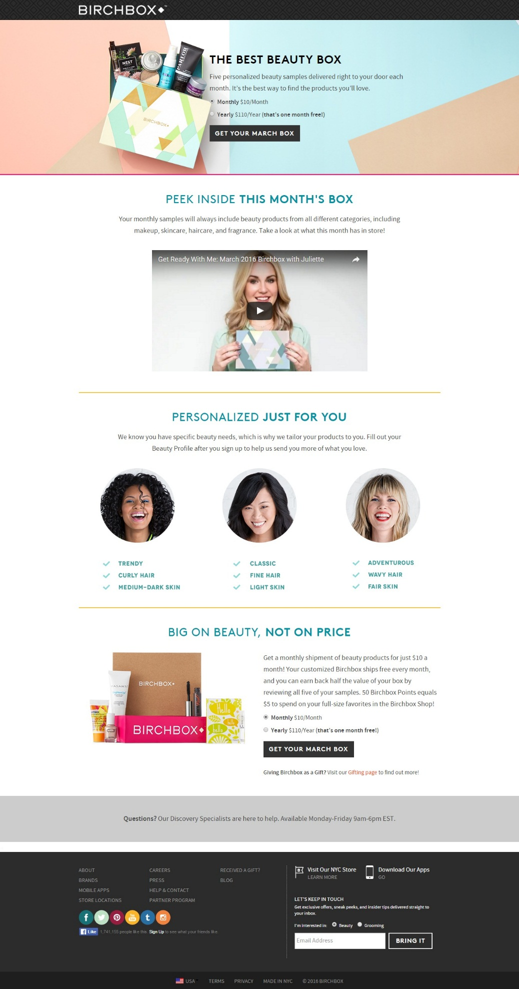
After clicking on the irresistible yet striking CTA, the subscribers’ land on their landing page, designed specifically for their March Box. This landing page can be considered as one of the tempting and high-converting landing pages because it not only carries the persona of its email campaign, but also takes care of above and below the fold essentials. According to one of the conducted surveys, landing pages that contain videos, boost the conversion rates up to 86%. So, what makes this a high-converting landing page?
- Beautifully customized Johnson box
- Curiosity bringer CTA above the fold
- Compelling copy
- Video that instantly steals the glimpses
- Creative opt-in
- Below the Fold CTA
- Creating and highlighting a question section
- Footer with ample socials

Chanel
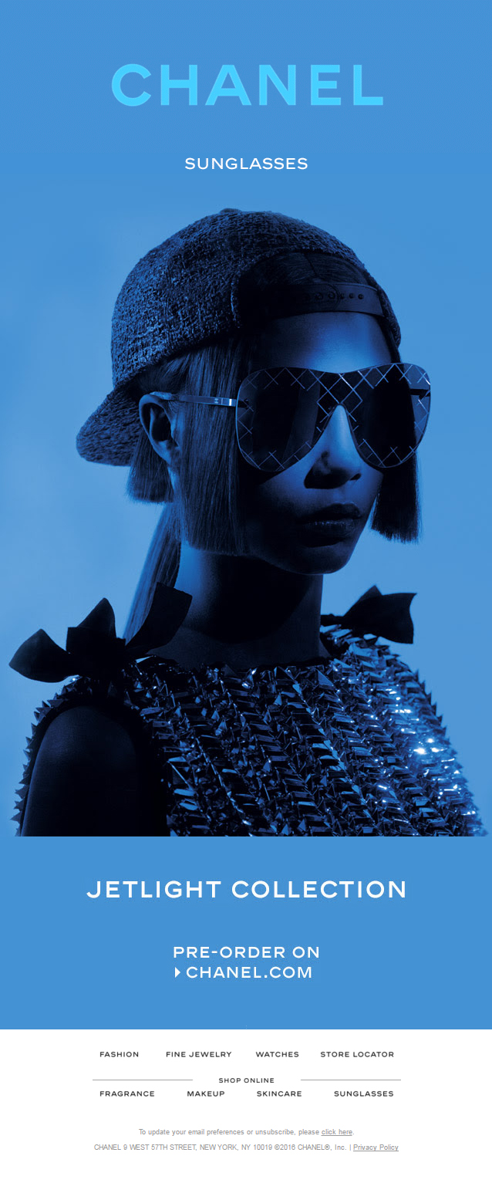
This is nonetheless a classy, chic, and bold email from Chanel with a dash of flash in the brand name. Though, the design of the email seems to be simple, but the provided image shouts clearly what Chanel is trying to say. The Pre-order CTA makes this email even more exclusive, which eventually becomes a click attainer.
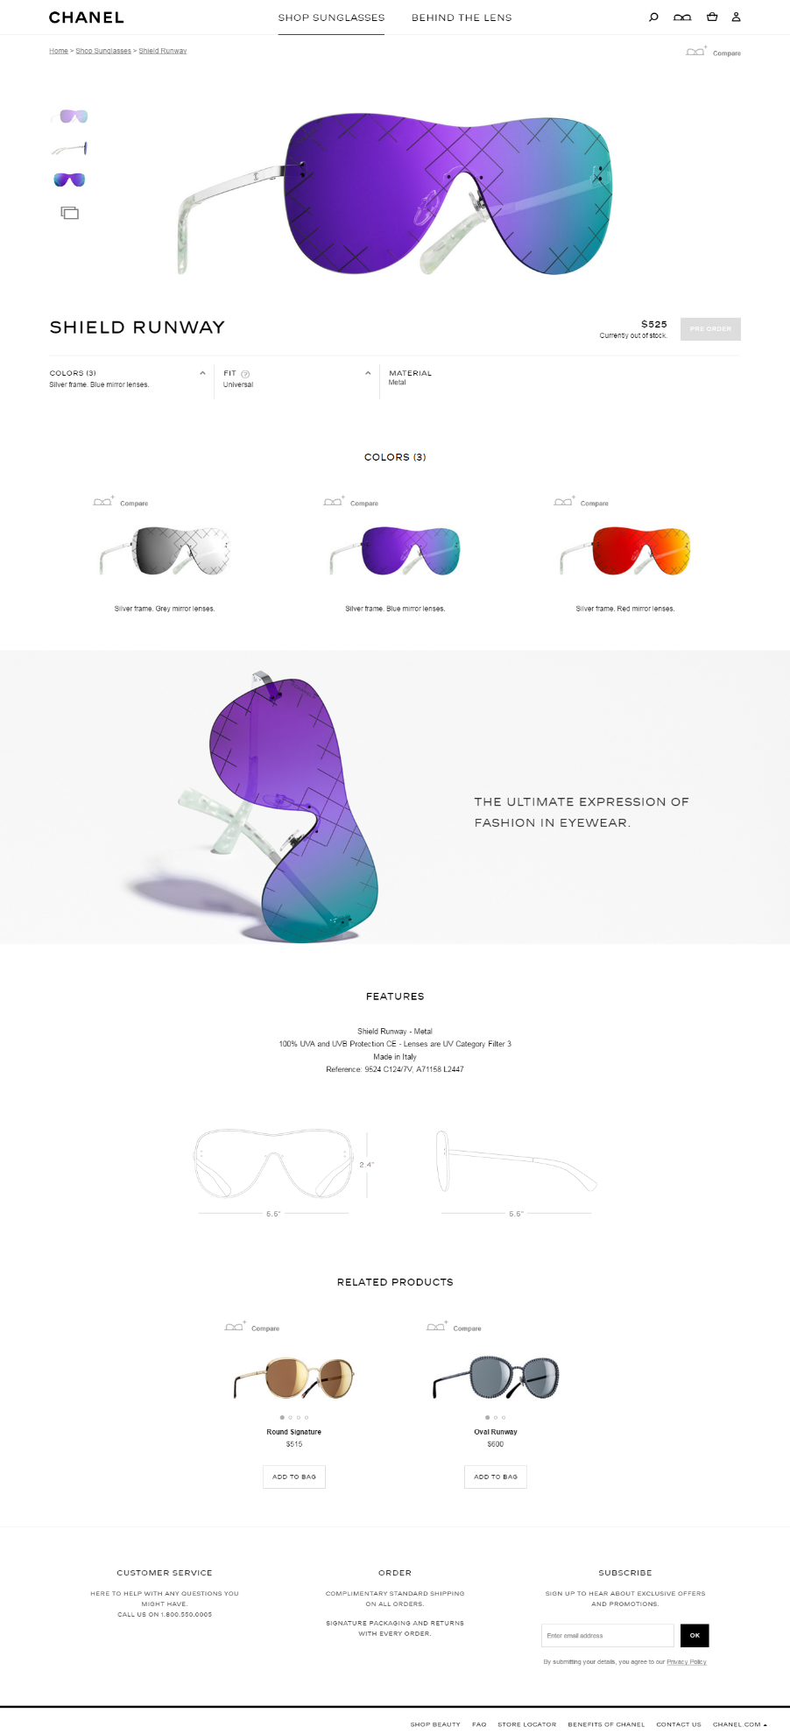
The CTA drives us to its landing page which gives us all the information of the product. The big yet bold images successfully get the subscribers irises stick to it. From colors to frame everything is there in the landing page, which makes it a heart winning and lead gathering landing page.
Dolce & Gabbana
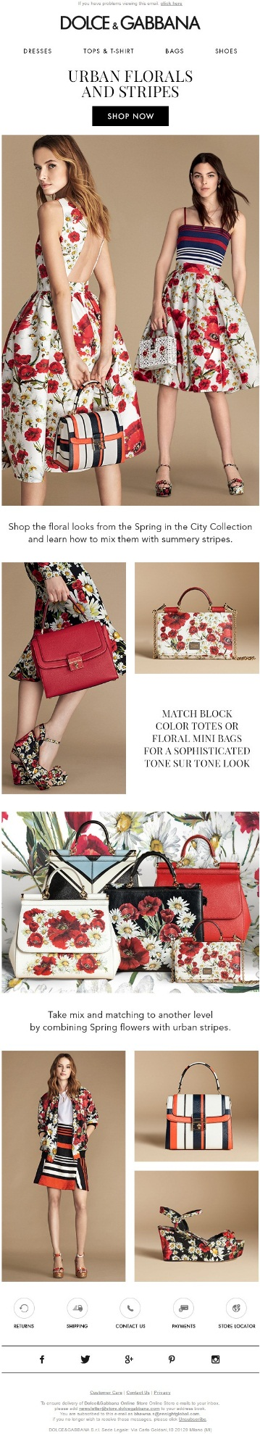
Next in the list of tempting and converting landing pages is Dolce & Gabbana. Their beautifully created email that successfully spreads the floral theme throughout the email. D&G wisely crafted the email by keeping above and below the fold phenomena in mind. Everything is sectioned in an organized way which makes this email unavoidable.
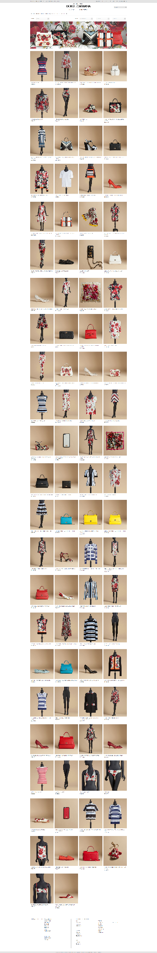
This email campaign specific landing page from D&G follows the rule of thumb, when it comes to a high-converting landing page. Showcasing multiple products on a single page so that the user do not have to swap through various webpages is a wise and brilliant move. The product description along with their price is another great thing which gives users a hassle free experience and helps them in making a buying decision.

Ginger
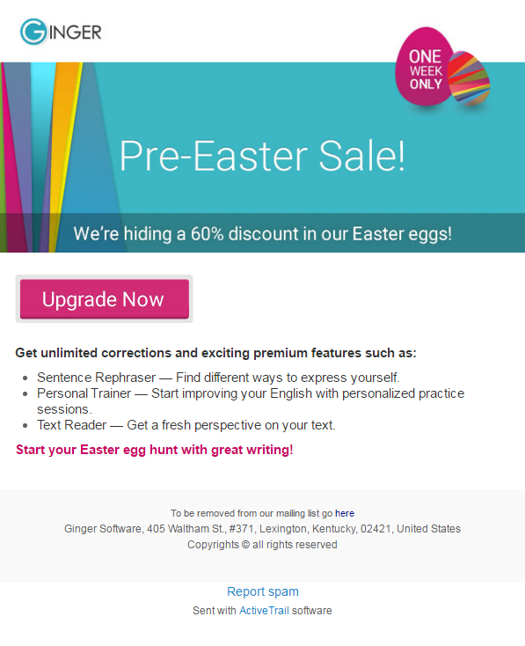
Simplicity is Ginger’s most powerful marketing tool that touches a chord with the customer. Ginger on the other hand brings a simple, specific, and informative email that tells you exactly what to do. The given CTA is specific and gives the idea of where the subscriber will reach after clicking on it. The copy is crisp, straight to the point and informs about the benefits of using Ginger. The Easter sale is displayed pretty well in the email and also make this creative a hard to miss.
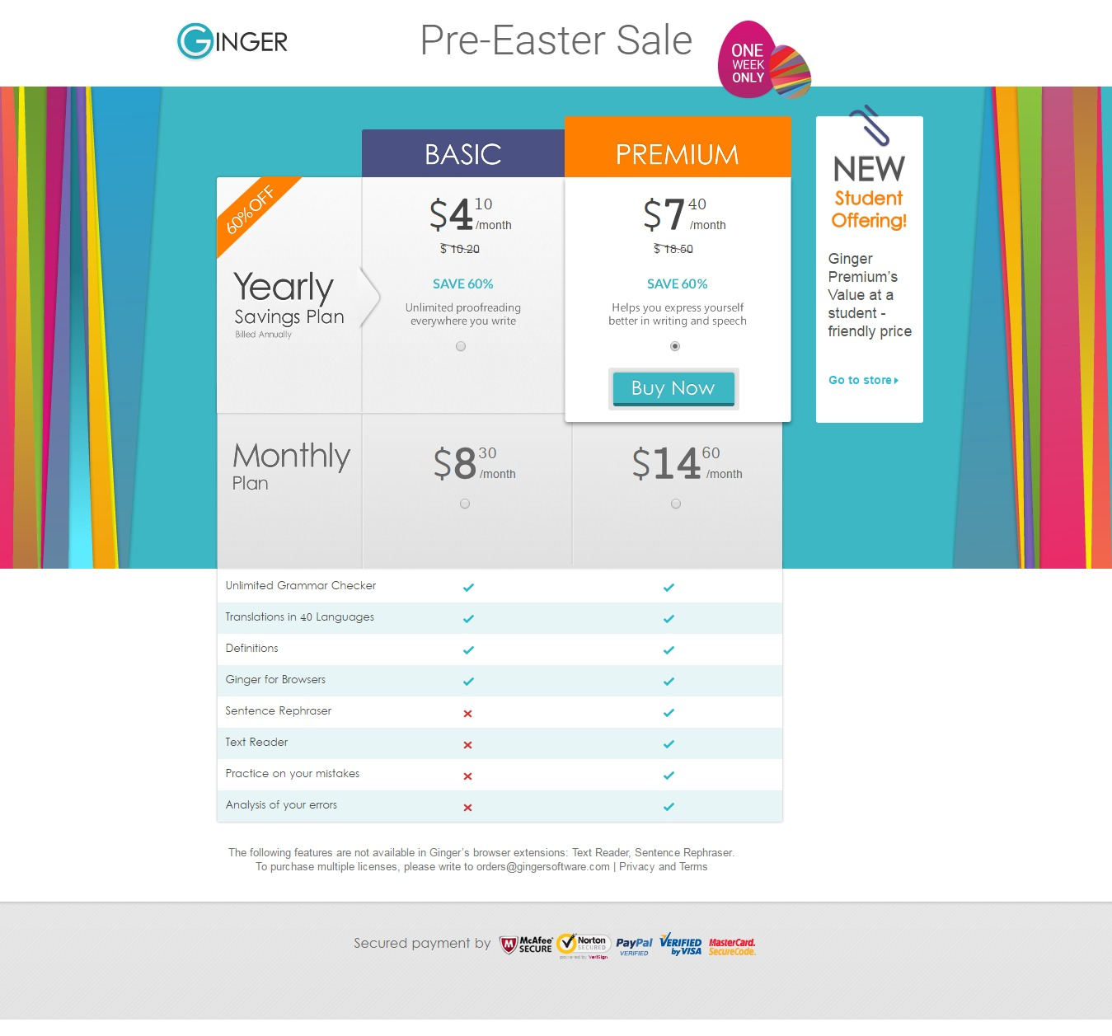
Ginger email’s better half, the landing page contains all the things which the email is trying to represent. Ginger too went an extra mile to make this landing page a converting one by placing the CTA above the fold. It also includes the information of the user will benefit from after upgrading his / her account.

McDonalds
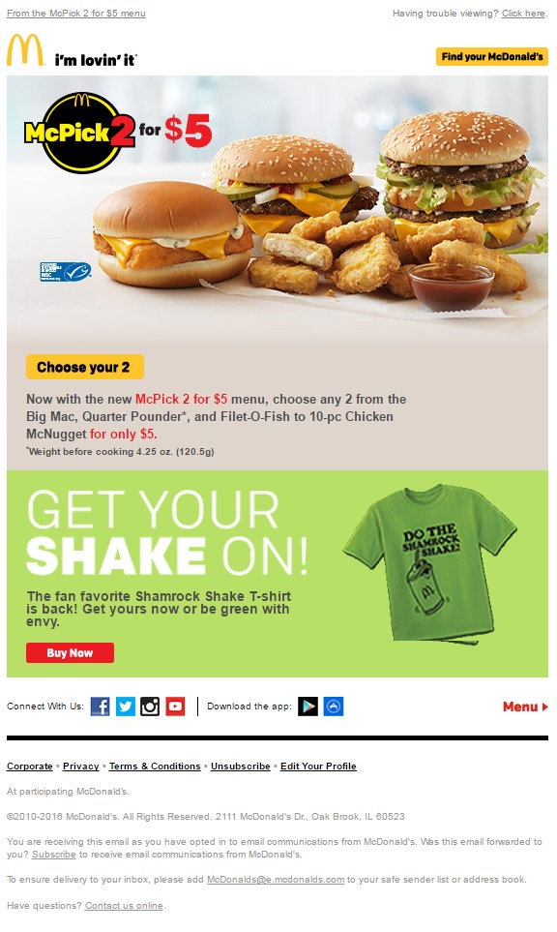
Apart from making mouthwatering burgers, McDonalds form such creative which are delicious to your eyes. The moment users see both burgers and offer in a single email, the CTA attains a click. The included GIF in the email increases its oomph factor and the juxtaposed colors bring the WOW element.
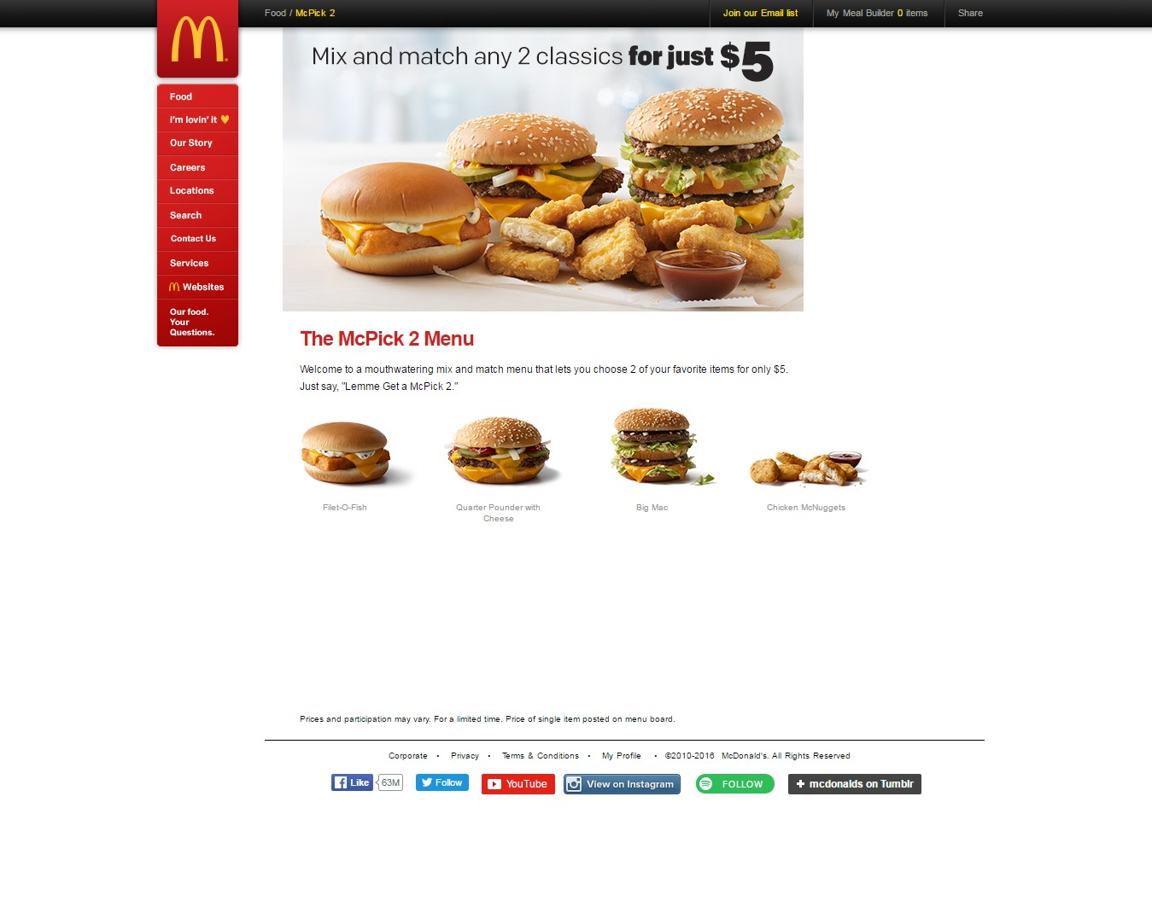
The landing page of this email features even a bigger image of the product which increases its appeal. The presented offer is bold & highlighted accurately which collects the focus right after arriving on the landing page. What makes this landing page a conversion deriver is it’s above the fold strategy. According to one of the surveys done with eye tracking device, images that are placed above the fold attains user’s maximum attention. Taking a cue from it, McDonalds is not only brilliant in titillating the taste buds, but winning the subscribers’ attention with their enticing creative’s as well.

Tiffany & Co.
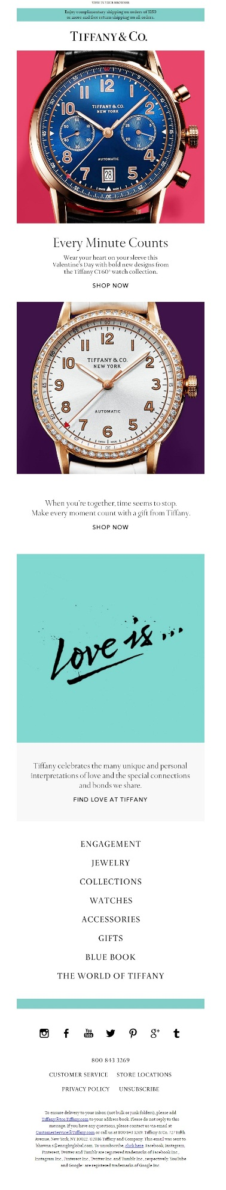
What is great about this email? Well, the name of the brand says it all. :D
Apart from the brand, Tiffany’s is known for its creative emails that are not only glimpse stealing but also really hard to ignore. The email is long enough to give a detailed look of the offered product. Multiple CTAs are there to make this creative irresistible.
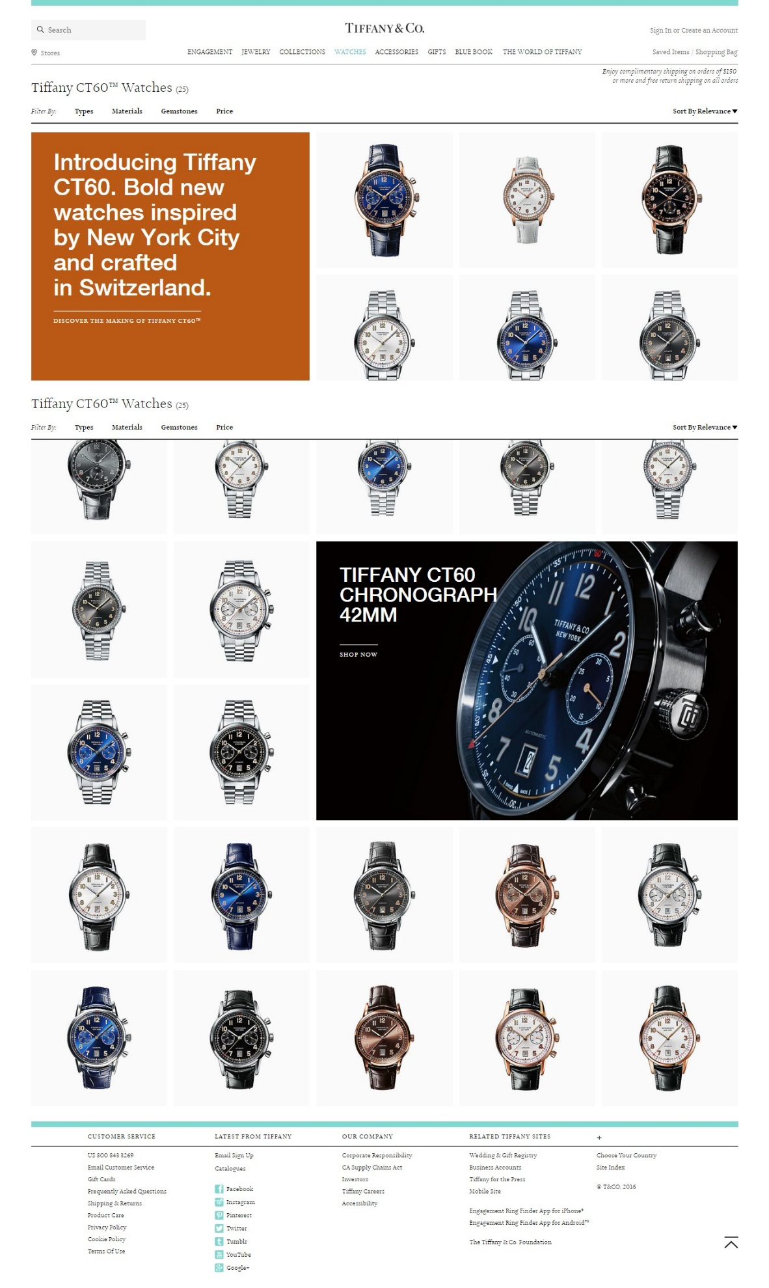
Right after clicking the CTA, the first thing which grabs the attention on an instant note is the copy highlighted in white color. Even though ample watches are showcased there, Tiffany doesn’t fail to highlight the star product. A bigger image is highlighted in below the fold which is an excellent use of above and below the fold in a landing page.
Wrapping up
At a time when most inbound marketers are ignoring this email-landing page power couple, 48% of suave marketers are taking advantage of it by crafting email campaign specific landing pages and pulling out 7X the leads. Are you one of them?
Monks can help you design and code beautiful email templates and landing pages to fuel conversion rates. Get in touch with us now!

